PROJECT DOCUMENTATION PHASE

Date | 28 SEPTEMBER 2026
Team ID | 6ab220cfbee0b08a2d2c63cd
Project Name | Auto Ticket Classification using FLOW DESIGNER

1. INTRODUCTION
Project title:
Auto ticket classification using flow designer
Team members:
Nancy Mary S: project developer
Padmini P: project developer
Akil K: project developer
Muthu Sangeetha K: project developer
Muthuesakki S: project developer

2. PROJECT OVERVIEW
Purpose:
The auto ticket classification using flow designer project is developed to automate the classification of it support tickets in a school environment.
The school it helpdesk receives different types of complaints such as wi-fi problems, projector failures, password issues, and slow computer problems. Normally, it staff manually review each ticket and assign a category and subcategory.this project uses servicenow flow designer to automatically analyze the ticket description and classify the issue based on predefined keywords. This reduces manual effort and improves ticket routing efficiency.
Features:
- Automatic ticket classification.
- Automatic category assignment.
- Automatic subcategory assignment.
- Dependent category and subcategory fields.
- Automatic email notification.
- Auto-generated ticket number.
- No-code implementation using flow designer.
- Easy maintenance and scalability.
Classification Examples:
Keyword / Issue | Category | Subcategory
Wifi / Network | Network | Wi-Fi
Projector | Hardware | Projector
Password / Login | Access | Forgot Password
Slow / Hanging | Performance | Slow Computer

3. ARCHITECTURE
Frontend:
The project uses the servicenow platform interface for creating and submitting it support tickets.
The User Provides:
  - Caller
  - Short Description
  - Description
The system then processes the ticket through flow designer.
Backend:
The Backend Functionality Is Implemented Using Servicenow Flow Designer.
The flow is triggered when a new record is created. It checks whether the category field is empty and then analyzes the short description. Based on the matching condition, the system updates the category and subcategory fields.
Backend flow:
New ticket
↓
Record created trigger
↓
Check category is empty
↓
Analyze short description
↓
If / else if conditions
↓
Update category & subcategory
↓
Send email
Database:
The project uses a custom servicenow table named: Incident workflow
The table stores ticket records and contains fields such as:
- Number
- Caller
- Category
- Subcategory
- Short description
Description:
- State
- Assigned group
- Assigned to
Database classification:
Field | type
Number | auto number
Caller | reference
Category | choice
Subcategory | choice
Short description | string
Description | string
State | choice
Assigned group | reference
Assigned to | reference

4. SETUP INSTRUCTIONS
Prerequisites:
The following are required:
- Servicenow account/instance
- Web browser
- Access to flow designer
- Access to system definition
- Access to update sets
- Installation / configuration
Step 1: create update set
Open all → system update sets → local update sets.
Click new.
Name it project update set.
Set state as in progress.
Set application as global.
Save.
Select make this my current set.

Step 2: create custom table
Create a table named: Incident workflow
Enable auto number and create the required fields.
Step 3: configure fields
Create the required fields such as category, subcategory, short description, description and state.
Step 4: configure dependency
Make subcategory dependent on category.
Examples:
Network → wi-fi
Hardware → projector
Access → forgot password
Performance → slow computer
Step 5: create flow
Create a new flow named: Auto classify school it tickets
Application: global.

5. FOLDER STRUCTURE
Since this project is developed in servicenow there is no traditional client and server folder structure.

The project structure can be represented as:
Auto ticket classification
│
├── update set
│ └── project update set
│
├── custom table
│ └── incident workflow
│
├── fields
│ ├── number
│ ├── caller
│ ├── category
│ ├── subcategory
│ ├── short description
│ ├── description
│ ├── state
│ ├── assigned group
│ └── assigned to
│
├── flow designer
│ └── auto classify school it tickets
│
└── email notification
└── ticket confirmation

6. RUNNING THE APPLICATION
The application is executed within the servicenow instance.
Process:
Login to servicenow.
Open the incident workflow table.
Create a new ticket.
Enter the caller.
Enter the short description.
Save the record.
Flow designer is triggered automatically.
The system identifies the issue.
Category and subcategory are automatically populated.
Email confirmation is sent to the caller.
The flow uses record created as its trigger and checks whether category is empty.

7. API DOCUMENTATION
API status:
This project does not use custom rest apis or external apis.The automation is implemented directly using servicenow flow designer.
Flow actions:
Action | purpose
Record created | starts the flow
If condition | checks ticket description
Update record | updates category/subcategory
Send email | sends ticket confirmation

Example:
Input:
Short description: Wifi not working in library
Output:
Category: network
Subcategory: wi-fi
8. AUTHENTICATION
The project uses the authentication and access-control mechanism provided by the servicenow platform.
Users must access the servicenow instance through authorized accounts.The project also validates that only authorized users can access or modify ticket data.

9. USER INTERFACE
The user interface is provided through the servicenow ticket form.
Main ui components
Caller field
Short description field
Description field
Category field
Subcategory field
State field
Assigned group
Assigned to

10. TESTING

The project was tested using different types of it support tickets.
Test case 1 – wi-fi issue
Input:
Wifi not working in library
Expected result:
Category → network
Subcategory → wi-fi
Actual result:
Passed.An email was also sent to the caller.
Test case 2 – projector issue
Input:
Projector not turning on
Expected result:
Category → hardware
Subcategory → projector
Actual result:
Passed.An email was sent to the caller.

Testing summary:
Test case | expected result | status
Wi-fi issue | network → wi-fi | pass
Projector issue | hardware → projector | pass
Password issue | access → forgot password | pass
Slow computer | performance → slow computer | pass

11. SCREENSHOTS

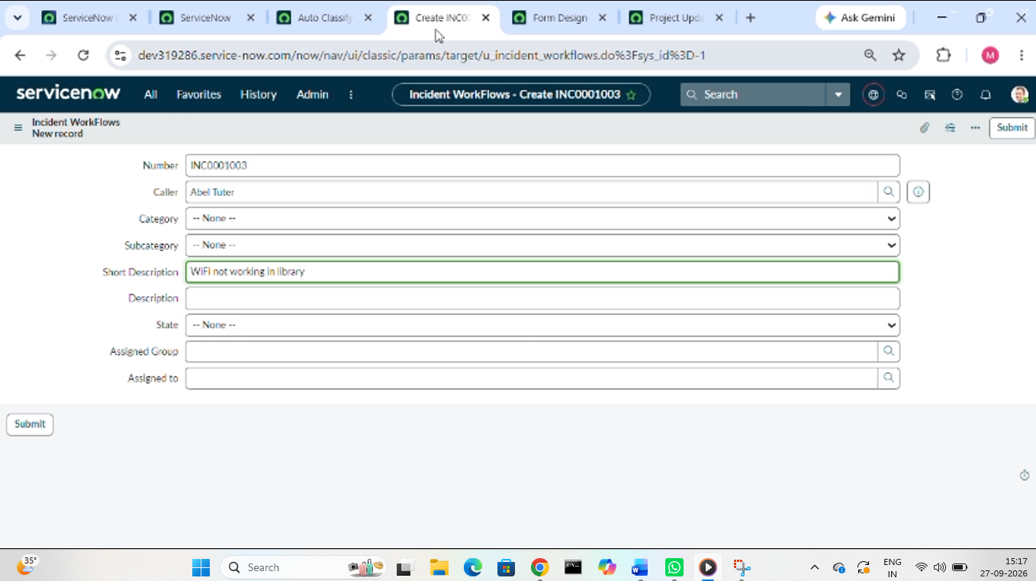

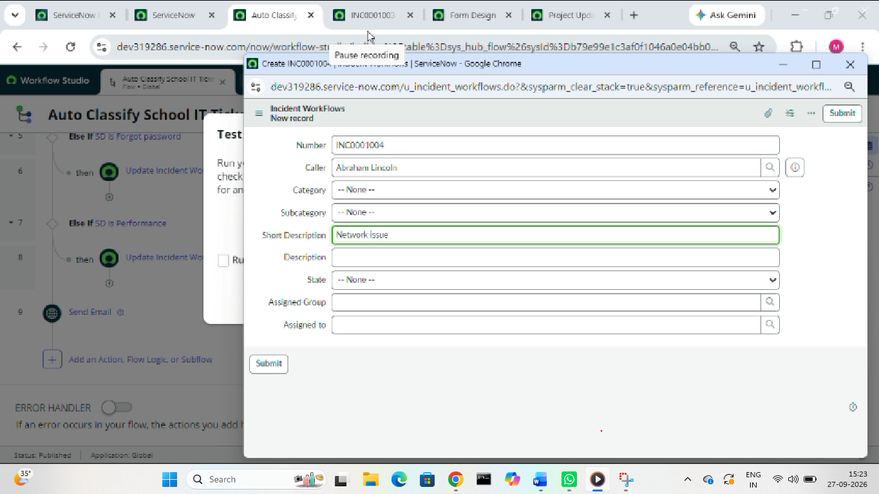

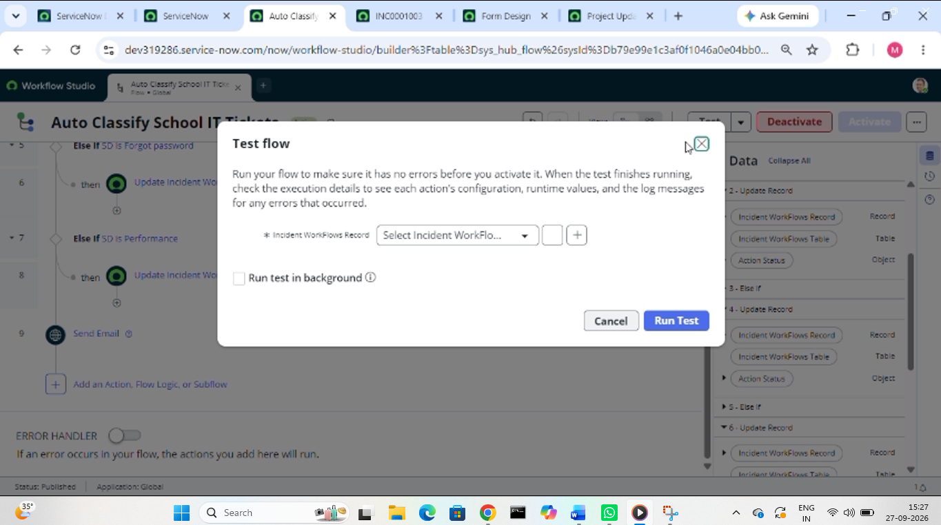

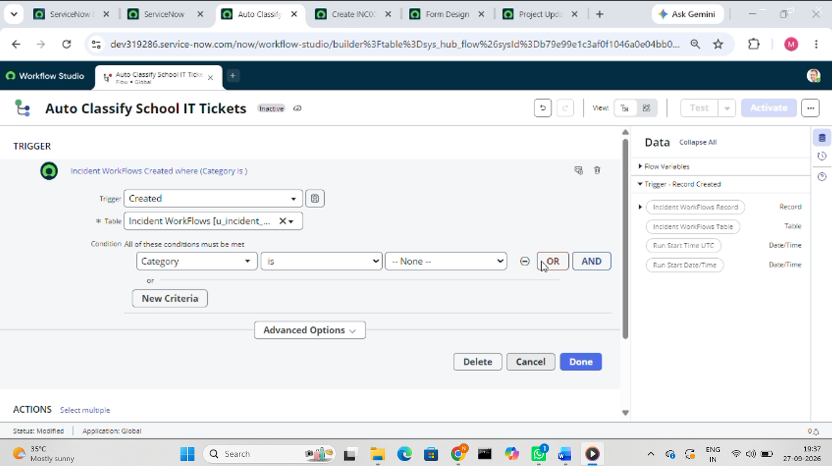

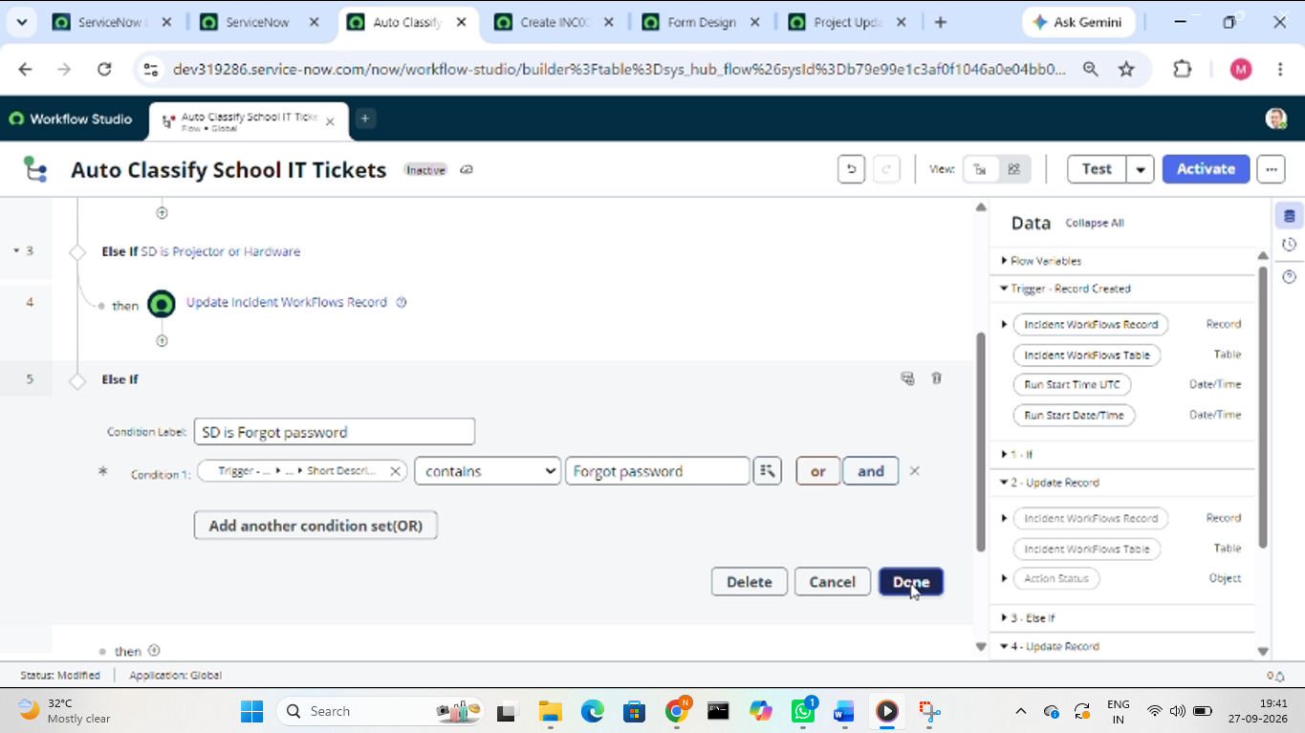

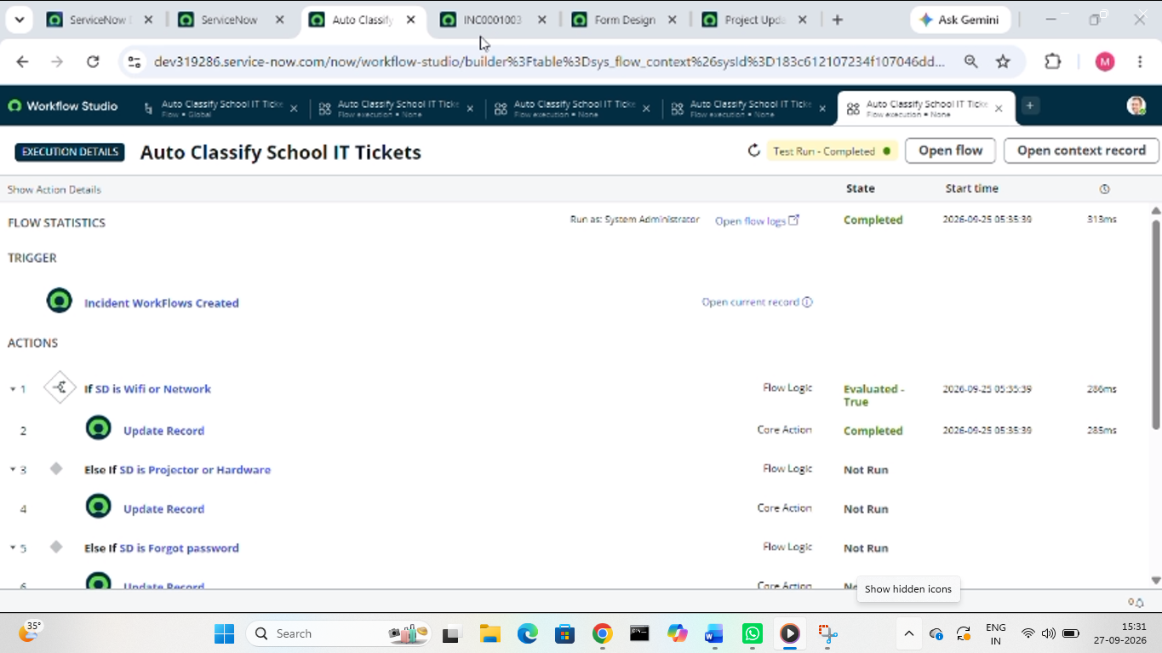
12. KNOWN ISSUES
The current system has some limitations:
- Classification depends on predefined keywords.
- Unknown issue descriptions may not be classified automatically.
- New issue types require additional flow designer conditions.
- Incorrect or unclear descriptions may not match the predefined conditions.
- The system currently supports only the configured categories and subcategories.

13. FUTURE ENHANCEMENTS
The project can be extended with:
Automatic assignment of tickets to it support teams.
Sla tracking.
Advanced reporting dashboards.
Additional ticket categories.
More keyword conditions.
Predictive intelligence.
Advanced automated classification.

Final project flow:
Student / teacher
↓
Create it ticket
↓
Incident workflow table
↓
Flow designer trigger
↓
Keyword analysis
↓
Category + subcategory
↓
Update ticket
↓
Email confirmation
↓
It helpdesk

